**Lab Assignment 4**

**Name - Kummandas meena (24215011106 ) Date: 31/01/25**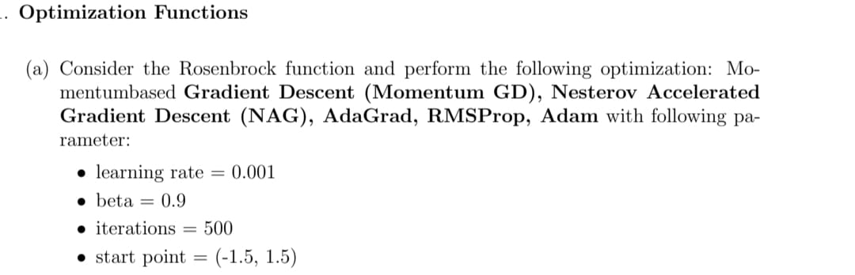

**import numpy as np**

**import matplotlib.pyplot as plt**

**# Define the Rosenbrock function**

**def rosenbrock(x, y):**

**return (1 - x)**2 + 100 * (y - x**2)**2**

**def rosenbrock_grad(x, y):**

**df_dx = -2 * (1 - x) - 400 * x * (y - x**2)**

**df_dy = 200 * (y - x**2)**

**return np.array([df_dx, df_dy])**

**def optimize(method, x, y, alpha, beta, iterations):**

**v = np.zeros(2)**

**G = np.zeros(2)**

**m = np.zeros(2)**

**path = []**

**for t in range(1, iterations + 1):**

**grad = rosenbrock_grad(x, y)**

**if method == "Momentum GD":**

**v = beta * v + (1 - beta) * grad**

**x, y = np.array([x, y]) - alpha * v**

**elif method == "NAG":**

**grad = rosenbrock_grad(x - beta * v[0], y - beta * v[1])**

**v = beta * v + alpha * grad**

**x, y = np.array([x, y]) - v**

**elif method == "AdaGrad":**

**G += grad**2**

**x, y = np.array([x, y]) - alpha * grad / (np.sqrt(G) + 1e-8)**

**elif method == "RMSProp":**

**G = beta * G + (1 - beta) * grad**2**

**x, y = np.array([x, y]) - alpha * grad / (np.sqrt(G) + 1e-8)**

**elif method == "Adam":**

**m = beta * m + (1 - beta) * grad**

**v = beta * v + (1 - beta) * grad**2**

**m_hat = m / (1 - beta**t)**

**v_hat = v / (1 - beta**t)**

**x, y = np.array([x, y]) - alpha * m_hat / (np.sqrt(v_hat) + 1e-8)**

**path.append((x, y))**

**return path**

**x0, y0 = -1.5, 1.5**

**alpha = 0.001**

**beta = 0.9**

**iterations = 500**

**methods = ["Momentum GD", "NAG", "AdaGrad", "RMSProp", "Adam"]**

**paths = {method: optimize(method, x0, y0, alpha, beta, iterations) for method in methods}**

**# Create a grid for contour plot**

**x_vals = np.linspace(-2, 2, 400)**

**y_vals = np.linspace(-1, 3, 400)**

**X, Y = np.meshgrid(x_vals, y_vals)**

**Z = rosenbrock(X, Y)**

**# Plot optimization paths separately**

**fig, axes = plt.subplots(2, 3, figsize=(18, 12))**

**axes = axes.flatten()**

**for i, method in enumerate(methods):**

**ax = axes[i]**

**ax.contour(X, Y, Z, levels=np.logspace(-1, 3, 20), cmap='viridis')**

**path = np.array(paths[method])**

**ax.plot(path[:, 0], path[:, 1], label=method, marker='o', markersize=3, color='red')**

**ax.set_title(method)**

**ax.set_xlabel('x')**

**ax.set_ylabel('y')**

**ax.legend()**

**ax.grid(True)**

**# Remove extra subplot**

**fig.delaxes(axes[-1])**

**plt.suptitle('Optimization Paths on Rosenbrock Function')**

**plt.tight_layout()**

**plt.show()**

**Momentum GD: -0.8146775638661041 0.6717642926839041**

**NAG: 0.9590474567976796 0.9196040653397444**

**AdaGrad: -1.4587682336803645 1.5414195159824142**

**RMSProp: -1.1952631828184124 1.436179411032135**

**Adam: -1.1936506938736722 1.4338007212063029**

**GD final value: [-0.8675442 0.76071108]**

**SGD final value: [-0.8763019 0.7721509]**

**Mini-batch SGD final value: [-0.86608056 0.75880034]**

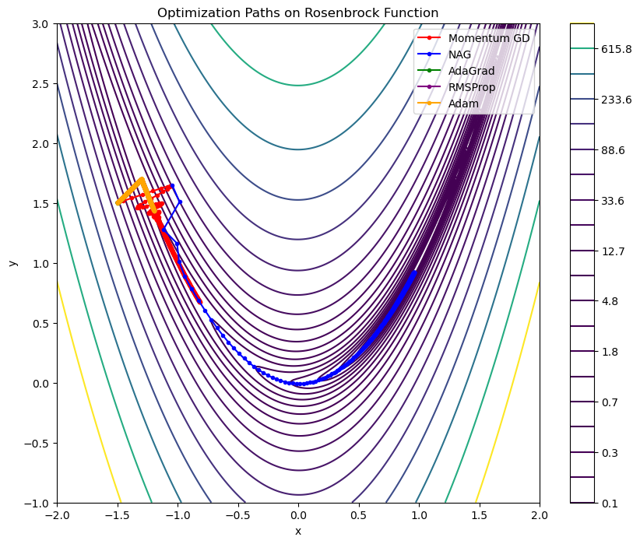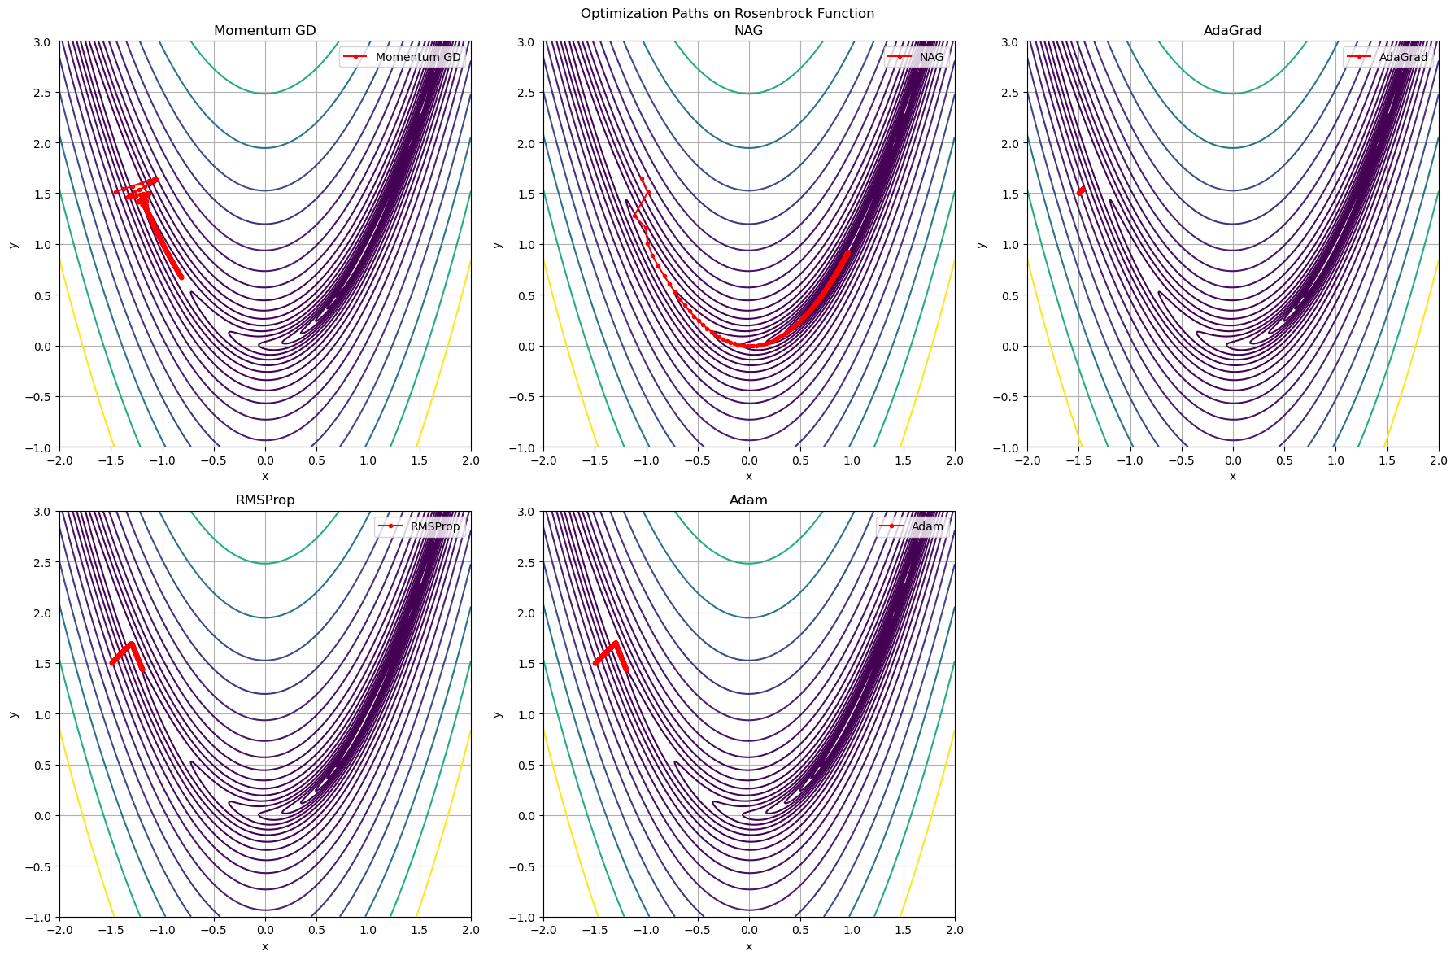

**Thank You Sir**